**Analyzing Differences Research Questions in Qualtrics (nominal or ordinal analysis variable)**

If analysis variable is nominal or ordinal level of measurement:

• use crosstabulation []

**How to get a crosstabulation in Qualtrics**

Example research question: Do men and women differ in where they purchase gift cards?

1. Identify your analysis variable (where gift cards are purchased)

2. Identify your grouping variable (gender)

3. In Qualtrics, navigate to the Reports page of your survey

4. On the left, highlight your analysis variable (Q36, where purchased)

5. Find Add Report Breakout on the left in the gray panel



6. In the dropdown menu for Add Report Breakout, select your grouping variable. (Q43, gender)

On the right, you will find a crosstabulation table for your grouping and analysis variables; you will have to scroll down below the bar graph and below a table of means to see this.

If Qualtrics is slow and seems to stall while Retrieving data…, you can reload the page but you will have to again highlight your analysis variable on the left.

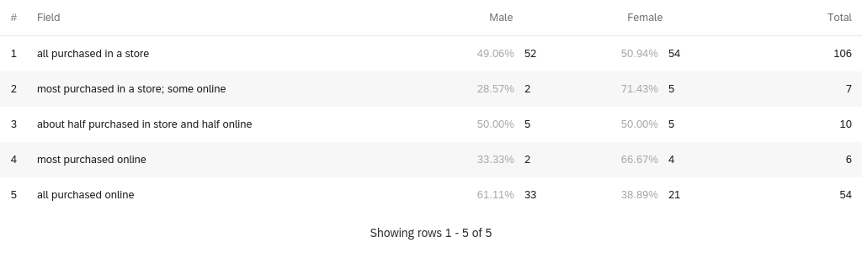

7. Qualtrics usually gives row percents by default; however, our groups are represented in columns, so we need column percents.

To obtain column percents, click anywhere on the crosstabulation table. A panel will appear on the right side. Find Use Row Totals in that panel and change it to Use Column Totals. (you can get rid of the panel now by clicking the X at the top)

We now have column percents.

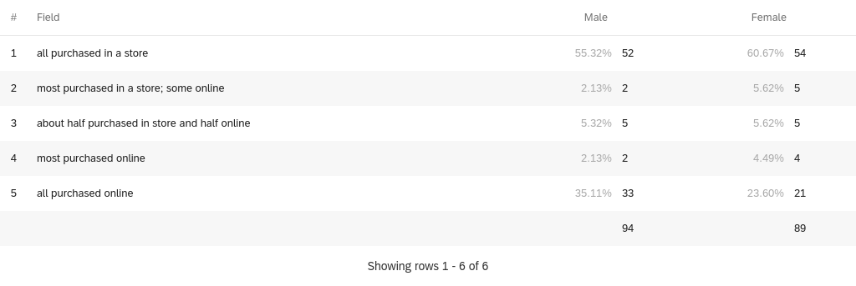

If you hover your cursor over the table, three dots will appear above Total on the right. If you click on the dots, you can export your crosstabulation as a csv or image file. Or you can take a screen shot instead.

Do not use the bar graphs in Qualtrics for your report. Instead, create your own bar graph in Excel using the data from your crosstabulation and be sure to graph percentages instead of counts. []

**Analyzing Differences Research Questions (interval or ratio analysis variable)**

If analysis variable is interval or ratio level of measurement:

• use mean comparison

**How to get means for comparison in Qualtrics**

Example: Do men and women differ in how satisfied they are with their gift shopping experiences?

1. Identify your analysis variable (satisfaction)

2. Identify your grouping variable (gender)

3. In Qualtrics, navigate to the Reports page of your survey

4. On the left, highlight your analysis variable (Q13, satisfaction)

5. Find Add Report Breakout on the left in the gray panel

6. In the dropdown menu for Add Report Breakout, select your grouping variable. (Q43, gender)

On the right, you will find a table of means for your analysis variable, broken down by your grouping variable; you will have to scroll down below the bar graph to see this.

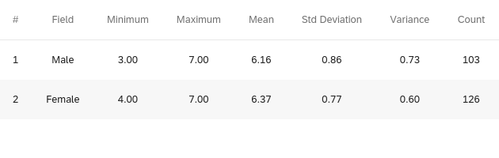

If you hover your cursor over the table, three dots will appear above Total on the right. If you click on the dots, you can export your means table as a csv or image file. Or you can take a screen shot instead. You can now create a bar or column graph in Excel that shows the means for each of your subgroups.

**Additional Considerations for Your Data Analysis Plans**

* Make sure every questionnaire question has an associated research question (except classification/demographic variables).
* You must have at least one differences research question